**Practical 5**

**Aim: Matrix Multiplication Application using Python and MapReduce**

**What is MapReduce ?**

A MapReduce is a data processing tool which is used to process the data parallely in a

distributed form. It was developed in 2004, on the basis of paper titled as "MapReduce:

Simplified Data Processing on Large Clusters," published by Google.

**Steps:**

1. Open terminal > Create two text files of matrix m1 and m2

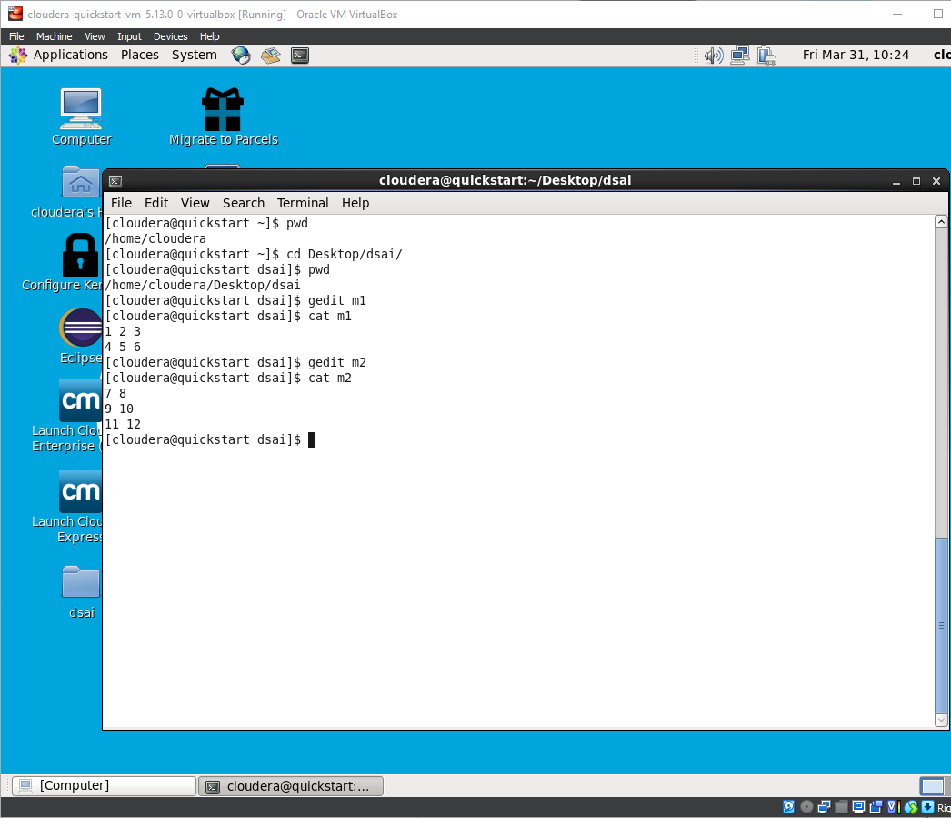

1. Create Mapper file mapper.py

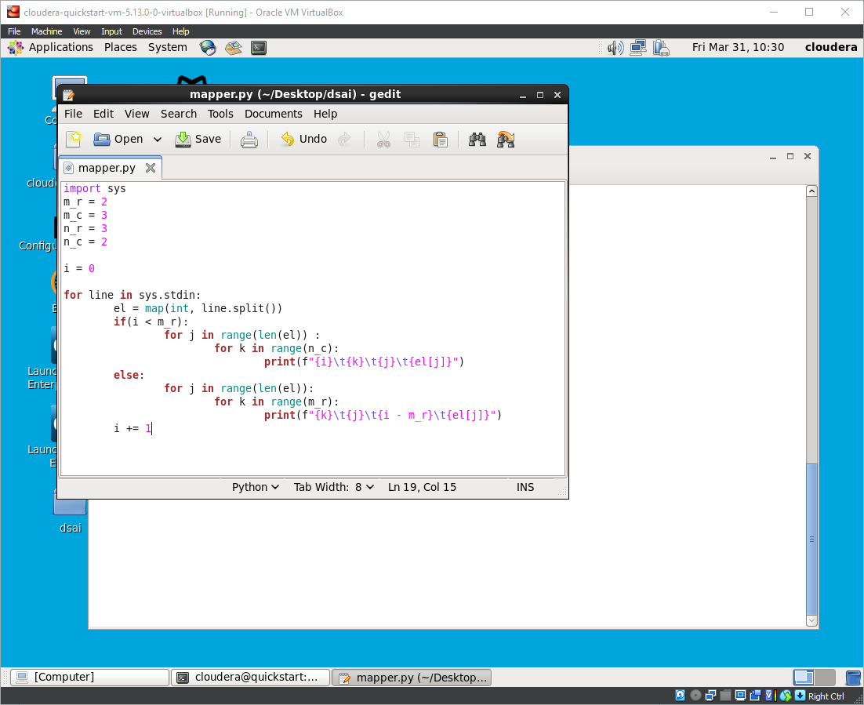

1. Create Reducer file reducer.py

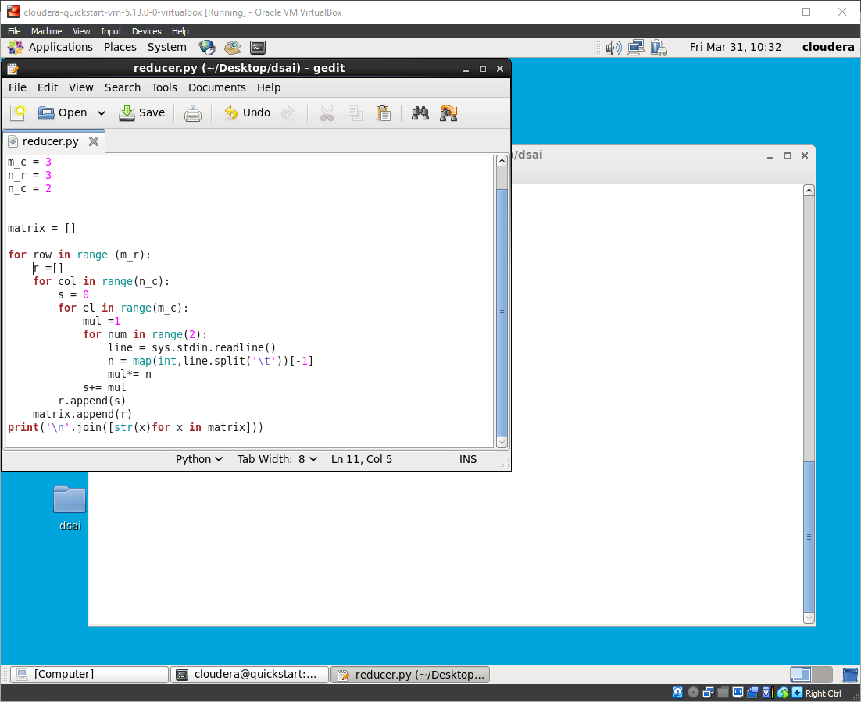

1. Running mapper.py

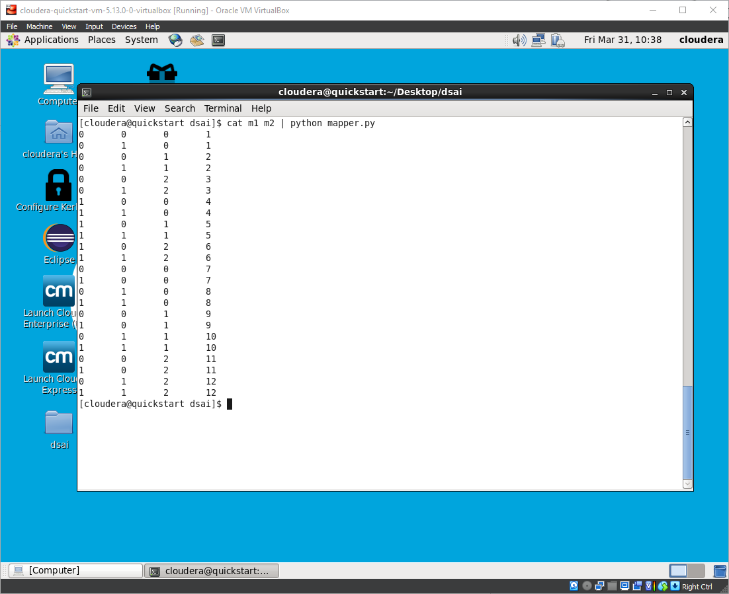

1. To get matrix multiplication run the following command

